**Jacket inventory on a first come basis. Please mail with check to   
Thunder Ridge Ski Area, 137 Birch Hill Road, Patterson, NY 12563**

**or call with a credit card to purchase a jacket.**

Thunder Ridge Race Team

**Team Uniform 2018-2019**



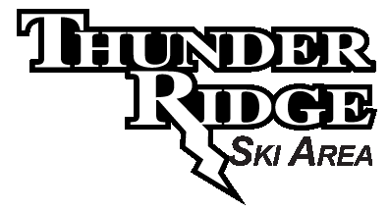

|  |  |  |
| --- | --- | --- |
| **ITEM** | **SIZE (circle)** | **PRICE** |
| **Helmets** |  |  |
| **UVEX** |  |  |
| ***Uvex Race+*** | 51-52, 53-54, 55-56,  56-57, 58-59, 60-61 | $189 |
| Black, White |  | $189 |
| 2018 Models - Colors |  | $219 |
| **POC** |  |  |
| ***Skull Orbic X*** | XS – S – M – L – XL - XXL | $199 |
| Black, White |  |  |
| ***Skull X*** |  | $159 |
| Black, White, Yellow |  |  |
| ***Skull Orbic X Spin*** |  | $249 |
| Hydrogen White, Black, Julia White, Bohrium Red, Hexane Yellow, Molybdenite Green, Lead Blue, Basketane Blue, Actinium Pink |  |  |
| **BRIKO** |  |  |
| ***Vulcano FIS Jr.*** | XS(48-52) S/M(53-56) | $180 |
| LightBlue Fluoro Orange, Orange Fluoro Black, Green Fluoro Orange, Yellow Fluoro Orange, Pink Black, White Ash, Light Blue Pink Explosion, Blue Sky White Ash, Black |  |  |
| ***Vulcano FIS*** *(Protetto included)* | 52,54,56,58,60,62,64 | $230 |
| LightBlue Fluoro Orange, Orange Fluoro Black, Green Fluoro Orange, Yellow Fluoro Orange, Pink Black, White Ash, Light Blue Pink Explosion, Blue Sky White Ash, Black, Purple Teal, Sulfuric Green |  |  |



**Thunder Ridge Race Team Members 25% off all 2018-2019 helmet & goggle orders.**

**Pre-season orders will be shipped to Thunder Ridge – no charge. *Individual orders will pay shipping to Thunder Ridge.**



Quilted Insulator w/ Left Chest & Back embroidery,

no youth sizing

|  |  |  |
| --- | --- | --- |
| **ITEM** | **SIZE (circle)** | **PRICE** |
| Youth Ski Jacket | 8 - 10 - 12 -14 | $305 |
| Mens Ski Jacket | XS - S - M - L - XL - XXL | $380 |
| **ITEM** | **SIZE (circle)** | **PRICE** |
| Women’s Quilted Insulator | XS - S – M – L – XL – 2XL | $145 |
| Mens Quilted Insulator | S - M - L - XL – 2XL – 3XL | $145 |
|  |  |  |
|  |  |  |
|  |  |  |

|  |  |  |
| --- | --- | --- |
| **ITEM** | **SIZE (circle)** | **PRICE** |
| **CHIN GUARD** |  |  |
| *Uvex* Slalom Chin Guard |  | $59 |
| *POC* Maxilla Orbic Chin Guard |  | $49 |
| *Briko* Vulcano FIS Chin Guard | Silver Med(52-58) Lg(60-64) | $40 |

**POC**



**UVEX**

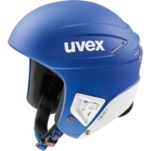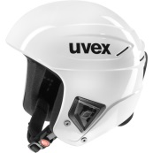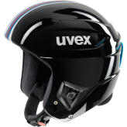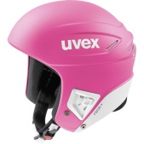

**BRIKO VULCANO FIS JR. ADJUSTABLE (U12-U14)**

[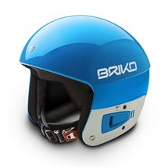](javascript:call_change('903'))[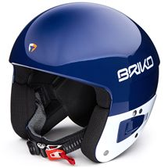](javascript:call_change('902'))[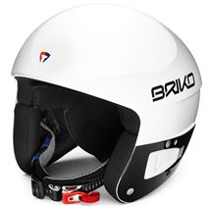](javascript:call_change('910'))[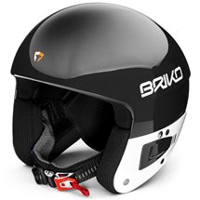](javascript:call_change('904'))[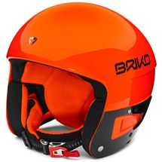](javascript:call_change('901'))[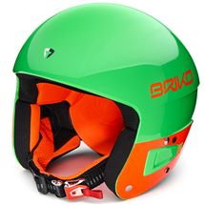](javascript:call_change('A57'))[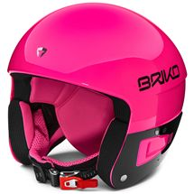](javascript:call_change('A30'))[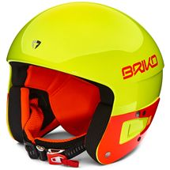](javascript:call_change('911'))[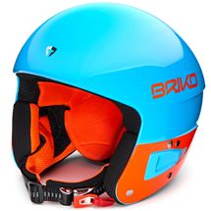](javascript:call_change('A56'))

**BRIKO VULCANO FIS (Protetto Included)**

[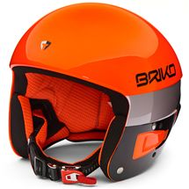](javascript:call_change('901')) [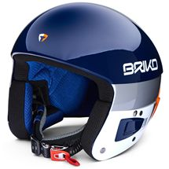](javascript:call_change('902')) [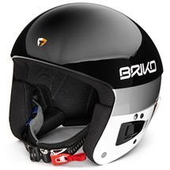](javascript:call_change('904')) [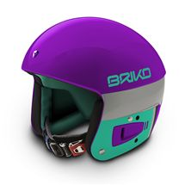](javascript:call_change('906')) [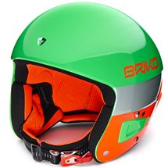](javascript:call_change('A57')) [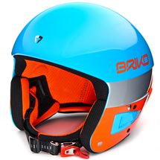](javascript:call_change('A56')) [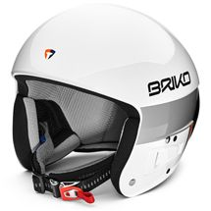](javascript:call_change('910')) [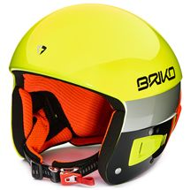](javascript:call_change('911'))

[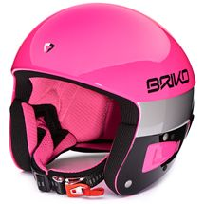](javascript:call_change('A30')) [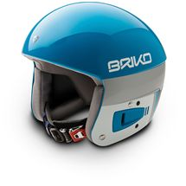](javascript:call_change('903')) [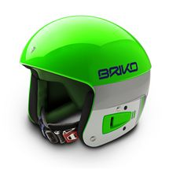](javascript:call_change('908'))